Case 1-Afr-Tanzania-Olduvai Gorge-Olduwan Tools-3.2 Mya

Figs. 1-2.Olduvai Gorge-Olduwan Tool-anvil-end pitted-3.2 Mya

**Case no.: 1**

**Accession Number:**

**Formal Label:** Tanzania-Olduvai Gorge-Olduwan Tool-anvil-end pitted-3.2 Mya

**Display Description:**

This end pitted anvil was used in conjunction with a hammerstone to access the pithy fruit of seeds or nuts or marrow from small bones (see Leakey 1971, fig. 104, no. 12). Olduwan tools represent the earliest stone tool industry in prehistory. This artifact is from the Olduvai Gorge, Tanzania and was made by Australopithecus Afarensis

**LC Classification:** [**GN776.T3**](http://luna.wellesley.edu/search~S1?/mq+GN776.T3+L42/mgn++776+t3+l42/-3,-1,,B/browse)

**Date or Time Horizon:** 3.2 Mya

**Geographical Area:** Olduvai Gorge, Tanzania.

**Map:**

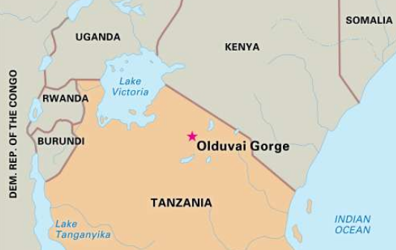

**Fig. 3. Location of olduvai gorge after https://cdn.britannica.com/700x450/05/19705-004-7B925915.jpg**

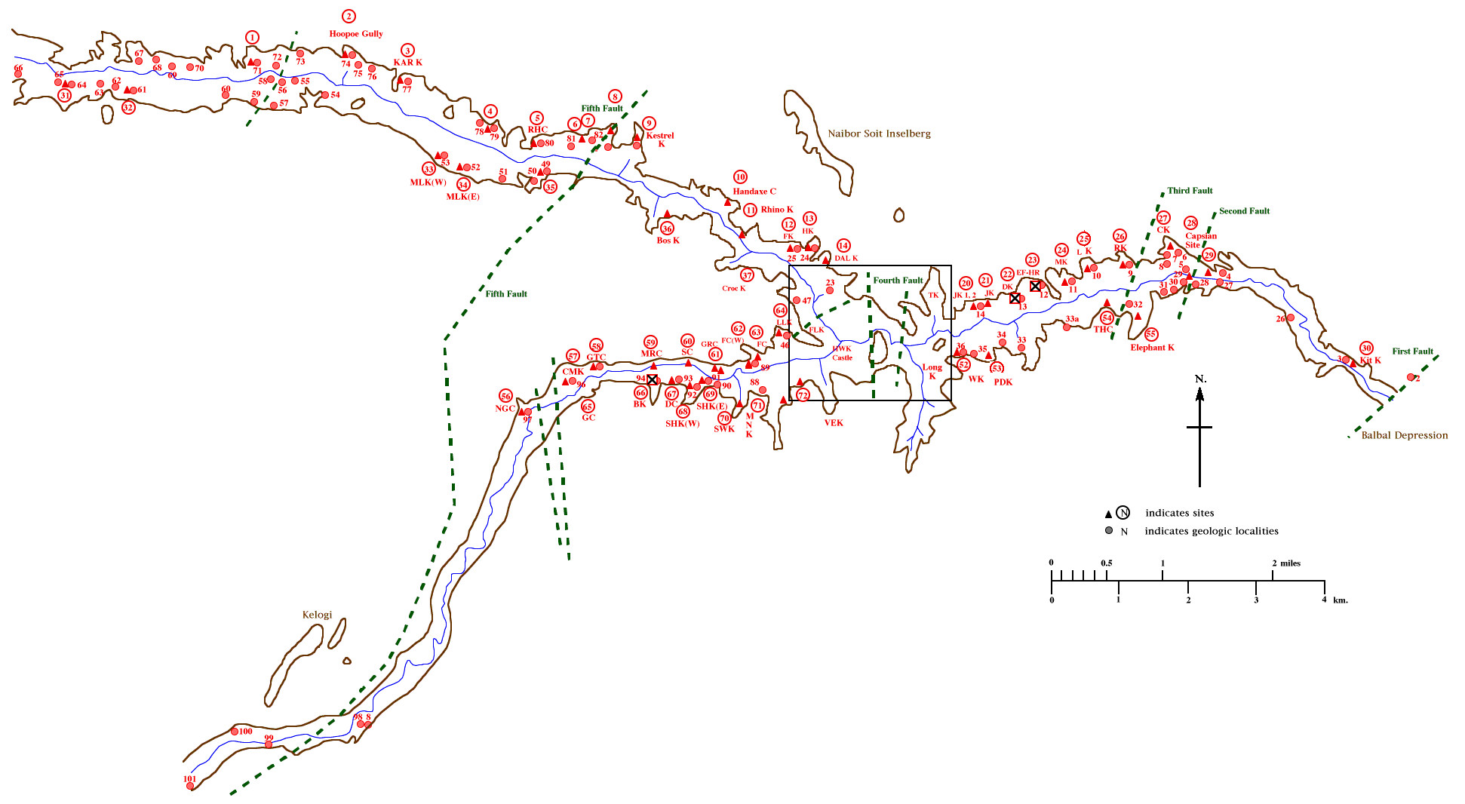

**Fig. 4. Olduvai Gorge after** [**https://archserve.id.ucsb.edu/courses/anth/fagan/anth3/courseware/OlduvaiArch/images/M**](https://archserve.id.ucsb.edu/courses/anth/fagan/anth3/courseware/OlduvaiArch/images/M) **asterMap.gif**

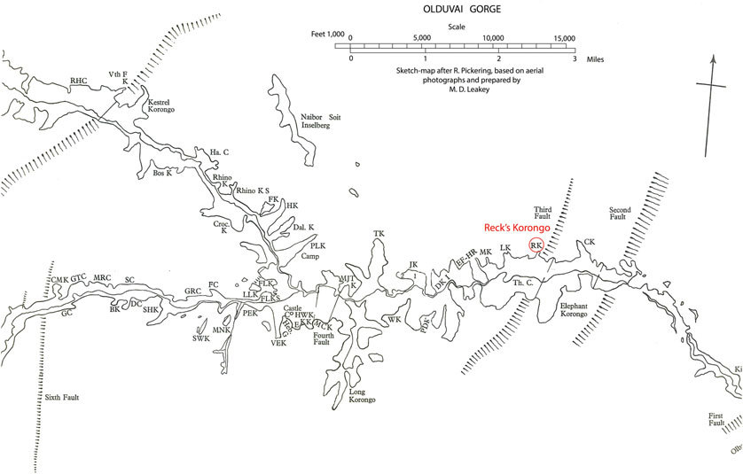

Fig. 5. Olduvai gorge  showing the location of the Olduvai Hominid 1 found (modified after L.S.B. Leakey, 1967). After https://www.researchgate.net/profile/Jean-Bernard_Huchet/publication/315593692/figure/fig2/AS:514490669244416@1499675542071/Map-of-Olduvai-Gorge-showing-the-location-of-the-Olduvai-Hominid-1-found-modified-after.jpg

**GPS coordinates:**

**Cultural Affiliation:** Olduwan tool industry

**Medium:** silicified sandstone

**Dimensions:**

**Weight:**

**Condition: original**

**Provenance:** Olduvai Gorge, Tanzania

**Discussion:**

**References:**

Leakey, Mary D. 1971 Olduvai Gorge. Cambridge: Cambridge University Press.